Class-V
SYLLABUS SESSION 2021-22

ENGLISH

Prescribed Books:

1 FRAMES – COURSE BOOK

2) FRAMES – LITERATURE READER

APRIL
Literature Reader : L-5 Don't be afraid of the dark(Poem)
Grammar : Subjectand Predicate

Vocabulary : Synonyms,Antonyms

MAY
Literature Reader : L-2 Mowgli and The Bandar-Log
Grammar : Sentences and its kinds
Transformation of sentences
Vocabulary : Homophones

JULY
LiteratureReader : L-6 At Sea with Uncle Ken
Grammar : Nouns and Its Kinds
Writing Skill : Autobiography

AUGUST
Main Course Book : L-9 Somebody’s Mother (Poem)
Grammar : Adjectives and its kinds
Degrees of comparison
Writing Skill : Picture composition

Revision for Half-Yearly Exam

SEPTEMBER
Grammar : Conjunctions

OCTOBER
Main Course Book : L-7 You are old, Father William (Poem)
Grammar : Subject-verb Agreement
Vocabulary : One word Substitution

1
NOVEMBER

Main Coursebook : L-6 A school with a difference

Grammar : Tenses
Writing skill : Letter writing (Formal)

DECEMBER

Main Course Book : L-14 The Refund
Grammar : Adverbs and kinds
Writing skill : Writing a Character Sketch
Vocabulary : Prefixes and Suffixes

JANUARY

Main Course Book : L-13 A Winter Night (Poem)
Grammar : Articles
Prepositions
Vocabulary : Similes

FEBRUARY

Writing-skill : Message Writing

REVISION FOR ANNUAL EXAM

कक्षा – पाँचवीं
विषय – हिंदी
सत्र –2021-22
पाठ्यक्रम

(अप्रैल+मई)
सुनहरी धूप : पाठ - १ (कविता) कांटों में राह बनाते हैं
पाठ - २ दया की जीत
पाठ - ३ होनहार बिरवान के होत चीकने (केवल व्याकरण )
पाठ - ४ कविता (लहरों का गीत )
सुनो कहानी : पाठ – १ गुलाब ,आम ,और कटहल
पाठ – २ प्रजा का राजा (केवल पठन कार्य )
पाठ -४ खरा सौदा
पाठ -५ कौन सच्चा ?कौन झूठा ?

व्याकरण: पत्र लेखन , अनुच्छेद लेखन , लिंग बदलो
सृजनात्मक लेखन : 1. नई कक्षा में मेरा पहला दिन
2. पेड़ हमारे मित्र
(जुलाई+अगस्त )

सुनहरी धूप : पाठ – ५ माउंट आबू
पाठ – ६ हेलन केलर(केवल व्याकरण )
पाठ – ७ नन्ही कलम से
पाठ – ८ अनमोल वचन

सुनो कहानी: पाठ – ४ अंगुलिमाल
पाठ – बलिदान ( केवल पठन कार्य )
पाठ-१० सच्चा हीरा
व्याकरण: क्रिया – काल, विलोम शब्द, अपठित गद्यांश
सृजनात्मक लेखन: 1. जब मैं विद्यालय देरी से पहुंचा
2. मेरे जीवन का सपना
3. सूरज की हमारे जीवन में आवश्यकता
सितम्बर अर्धवार्षिक पुनरावृति
वार्षिक परीक्षा पाठ्यक्रम (अक्तूबर से फरवरी तक)
(अक्तूबर से दिसम्बर)
पाठ – १० प्रायश्चित
पाठ – ११बुलंद भारत की तस्वीर( केवल व्याकरण)
पाठ – १२(कविता) सपना
पाठ – १३पैसों का पेड़
पाठ – १४खेल- दिवस
सुनो कहानी: पाठ –१३ रामलीला
पाठ –११ सच्ची कहानी
पाठ- १२ ज्ञान किसी की बपौती नहीं
व्याकरण: अशुद्ध ,शुद्ध शब्द व वाक्य , क्रिया -विशेषण, पत्र लेखन, संवाद
लेखन
सृजनात्मक लेखन: 1.काश! मैं रोबोट होता
2. जब मैंने पहली बार चाय बनाई
3. काश! मेरे पास जादुई छड़ी होती

(जनवरी+फरवरी)
सुनहरी धूप : पाठ – १५ दस आमों की कीमत
पाठ - १६ संकल्प (कविता)
सुनो कहानी : पाठ –१५ बहन का झूला (पठन कार्य)
व्याकरण: अनुच्छेद लेखन, अनेक शब्दों के लिए एक शब्द
सृजनात्मक लेखन: 1.जब मेरे घर चूहा घुस आया

CLASS-V

MATHEMATICS

Prescribed Book: Number Magic Part 5
Publisher: Ratna Sagar

April | Chapter 1: | Place Value
May | Chapter 2: | The Four Fundamental Operations
July
 | Chapter 2: | The Four Fundamental Operations
 |  | (continued)
 | Chapter 3: | Multiples and Factors
August
 | Chapter 4: | Fractions
 | Chapter 5: | Decimals
September | Revision for Half- Yearly
October | Chapter 12: | Money
November | Chapter 8: | Measurement
 | Chapter 9: | Area and Perimeter
December | Chapter 10: | Volume and nets
 | Chapter 6: | Geometry
 | Chapter 11: | Time
January | Chapter 13: | Data handling
 | Chapter 7: | Shapes and patterns (activity based)
February | Revision for Annual Examination

 |  |  | Syllabus |  |  |  |  | EVS  Prescribed Book: My green world Part -5  Publisher: Millennium
April | Chapter |  |  | : Our country
 | Chapter |  |  | : The Northern mountains
 | Chapter |  |  | : The Northern plains
 | Chapter |  |  | : The southern Plateau
May | Chapter |  |  | : The Coastal plains and the islands
 | Chapter |  |  | : The Great Indian Desert
July | Chapter |  |  | : How does our body work?
 | Chapter |  |  | : Eating right – healthy and junk food
 | Chapter |  |  | : Cleanliness and prevention of diseases
Aug | Chapter |  |  | : Study of plants
 | Chapter |  |  | : |  | 26 Natural calamities *
Sep | Revision for the Half yearly
Oct | Chapter |  |  | : British rule in India
 | Chapter |  |  | : |  |  |  | Indian National movement
 | Chapter |  |  | : |  |  |  | Towards Independence
Nov | Chapter |  |  | : Birth of a nation
 | Chapter |  |  | : |  |  |  | A new dawn
 | Chapter |  |  | : |  |  |  | Help I can‟t breathe*
Dec |  | Chapter |  |  | : |  | Mapping the world
 |  | Chapter |  |  | : |  | Simple Machine
 |  | Chapter |  |  | : |  | Force , work and energy
Jan |  | Chapter |  |  | : Protecting plants and animals*
 |  | Chapter |  |  | : |  | Materials and their properties
Feb |  | Revision for the Finals

*For these chapters no written work will be done.

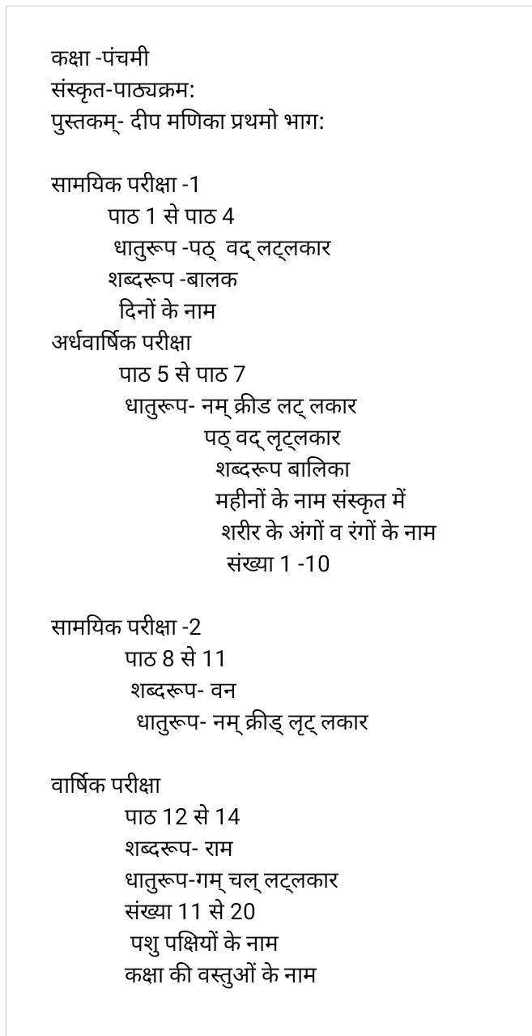

9

CLASS-V

FRENCH

Prescribed Book: Apprenons le Français 1

April : Les Salutations

Comptons Ensemble

May : Les Copains

July : Devinez

August : Dans La Classe

September : Revision

October

: Les Amis de Caroline

November

: Quel jour sommes-nous?

La famille de Manuel

December

: Les Vacances

January

: Le Drapeau de mon Pays

February

: Revision

CLASS-V

am

ART

Prescribed Book: I am an Artist-Part V

April to September

Fruit Basket, Step by Step Drawing , Spring Season, Seascape,

Beach Scene, Impression Art,Mehandi Design,

Writing Styles, Warli Art

I am an Artist:- Pg. no. 3 to 21

October to February

Village Scene, Holi Scene,Football Match, Mosaic Pattern,

Winter Scene, Christmas celebration,

Diwali Scene, Dussehra Scene, Doodling, Poster Design.

I am an Artist:- Pg. no. 22 to 40

10

CLASS-V

APRIL TO SEPTEMBER

- Ice-cream Stick Activity

- Rakhi Making Activity

- Pencil Shaving Activity

- Photo Frame Activity

- Paper Weight Activity

- Diya Decoration Activity

OCTOBER TO FEBRUARY

- Decorative Material Activity

- Paper Craft

- Leaf Art

- Match Stick Activity

- Aluminium Foil Activity

- Christmas Decoration Activity

11

CLASS-V

HEALTH AND PHYSICAL

EDUCATION(HPE)

April

: Athletics: Introduction, General rules and Regulation (1) padahastasana (2) makrasana

(3) danurasana (4) mathsysana

May

: Athletics: (track event starts 1) crouch start Bunch, Medium and Elongated 2) standing start

(1) vatyanasana (2) hanumanasana

(3) vrsehikasana (4) rajakapotasan

July

: Sprints- 100, 200 mts.

(1) halasana (2) janusirasana

(3) natarajasana (4) kukkutasana

August

: Table tennis-Introduction, Rules and Regulation,
co- Ordination, and conditioning work.
(1) paschimothanasana (2) bakasana

(3) gomukhasana (4) bhujangasana

September

: Basic and fundamental skill of table
tennis (1) Grip shake hand grip, pen hold
grip (2) Service-back spin, side spin, top
spin Knowledge about important
tournaments (national/international)

important sports personalities and sports
awards)

(1) baddha padamasana (2) marichyasana

(3) garudasana (4) padam sarvangasana

October

: Badminton-Introduction of the game and Rules and Regulation and Conditioning work.

- eka pada chakrasana (2) ushtrasana

- sirshapadangusthsana(4) vibhakta paschimottanasana

November

: Badminton- basic and Fundamental skill like

Grip-for hand grip, back hand,

Service- high lob service, short service-Knowledge

about important tournaments

(national/international level)

(1) trivikramasana (2) purna chakrasana

(3) koundinyasana (4) padma bakasana

12

December | : Badminton-Fundamental skills like:-
 | Defensive technique,Foot work,Strokes
 | Important sports personalities and sports awards
 | (1) omkarasana (2) purna dhanurasana
 | (3) setu bandha sarvagasana (4) sirshasana
January | :Kho- kho – Introduction of the game and
 | Rules and Regulations- important sports
 | personalities and Sports awards
 | (1) dandyaman janusirshasana (2) ) uttmita
 | paschimottanasana (3) ardha baddha
 | padmottanasana
 | (4) setu bandha chakrasana
February | : Kho-kho- fundamental skill- sitting, dine,
and March | chain,Pole running, chasing- knowledge
 | about important tournaments
 | (national/international level)
 | (1) virbhadrasana (2) mayurasana
 | (3) vatayanasana (4) vajrasana

